**Software Testing**

# What is software?

Software is a collection of specialized programs which takes user input and generate desire o/p.

# What is testing?

Testing is a process of checking whether the given s/w or application is generating desired o/p

# What is Software Testing

Process of checking completeness and correction of software with respect to the client's expectation.

OR

Software testing is a process, to evaluate the functionality of a software application with an intent to find whether the developed software met the specified requirements or not and to identify the defects to ensure that the product is defect-free.

# Resources involve in the software development

Customer/client/project-->Business Analyst (Gather requirement)-->Developer(Develop application as per requirement)-->Tester(Check correctness and completeness of functionality)-->Final product to customer

-Customer want some product

-BA gather all the requirements from customer

-BA then make documents(BRS-Business Requirement Specification) and send it to the developer

-Developer then develop the application as per client’s requirement

-Then developed product send to the tester

-Tester then test the application with positive and negative testing concepts

-Positive testing means suppose there is a name field. Tester test a field by entering credentials.

Name:Prasad

This is positive test by doing it in correct manner.

-Negative testive is dobe by entering wrong credentials in the field.For name field tester enter numbers.This number should not get accept.This is negative testing.

**What is Positive Testing?**

It is used to check whether our application works as expected or not. And if an error is detected at the time of positive testing, the test is considered as fail. A positive testing is a technique whenever a test engineer writes the test cases for a set of respective outputs.

In positive testing, the test engineer will always check for only a good set of values.

In other words, we can say that positive testing is a process where the system or an application is tested against the valid input data.

And the primary purpose of performing the positive testing is to validate whether the software does what it is supposed to do.

In simple terms, we can say that positive testing is implemented by providing a positive point of view.

For example, Numbers like 9999999.

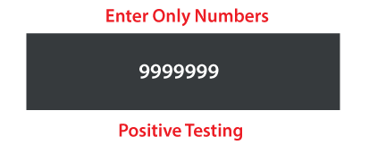

**What is Negative Testing?**

It is implemented to check how the application can gracefully handle invalid input or unpredicted user performance.

The fundamental purpose of executing the negative testing is to ensure the application's stability against the effects of different variations of improper validation data set.

Negative testing is also known as error path testing or failure. And it helps us to identify more bugs and enhance the quality of the software application under test.

Once the positive testing is complete, then only we can execute the negative testing, which helps to identify more bugs and enhance the quality of the software application under test.

We can say that the negative testing is executing by keeping the negative point of view in simple terms. For example, 99999abcde

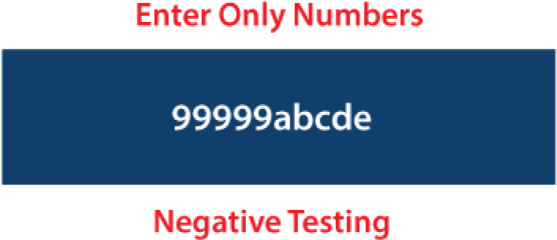

# Objectives Of Testing :

· To make sure that the end result meets the business and user requirements.

· To ensure that it satisfies the BRS that is Business Requirement Specification and SRS that is System Requirement Specifications.

· To gain the confidence of the customers by providing them a quality product.

· Finding defects

· Gaining confidence in and providing information about the level of quality.

· To prevent defects.

# How will you understand that Software has a bug?

1. The software doesn’t do something that the product specification says it should do.
2. The software does something that the product specification says it shouldn’t do.
3. The software is difficult to understand, hard to use

# What is Software Quality Assurance?

-Communication between customer and the BA is called SQA.

-SQA monitor and measure software development factors.

-Factors involve in SQA

1.To meet the customer requirement which type of application customer want and for which purpose. i.e. Banking domian

Telecom domain etc

2.To meet the customer Expectation

Privacy: Privacy include security. Suppose banking application gathering customer data which is sensitive so customer wants privacy

Performance: Software should balance load properly it should have to work properly in predefined load.

3.Costing of project

Project costing for MNC is per hour cost. Customer have to pay it.This payment depend upon resource utilization as well time to complete for project.

4.Timing Delivery

At the time of resource gathering and documentation time to compete for a project get decided.

If company exceeds the delivery time, then company have to pay penalty, that penalty is called escalation.

5.Maintainance

Maintenance is the part of service provided by the company after delivery of project If any problem occurs after delivering the project then company have to fix it.

# Projects-

Projects have two categories-

1.Critical Project

Eg:Banking Domain Project

Resources requirement:2 developer:1 tester like 100 dev : 50 tester

2.Normal Project

Eg:ERP System

Resource Requirement:3 developer:1 tester like 300 dev:100 tester

# Type of Software testing

We have various types of testing available in the market, which are used to test the application or the software.

With the help of below image, we can easily understand the type of software testing:

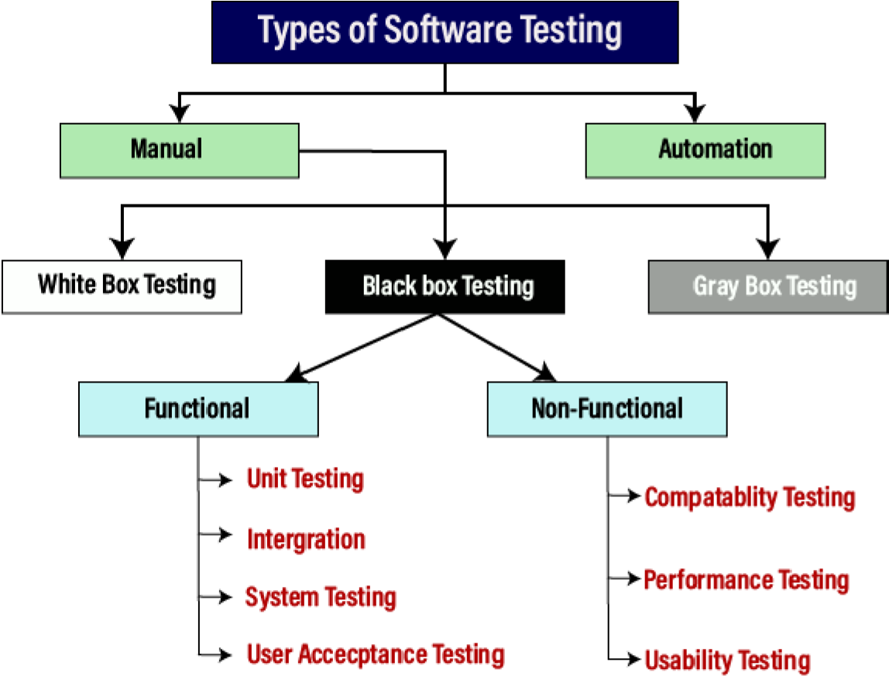

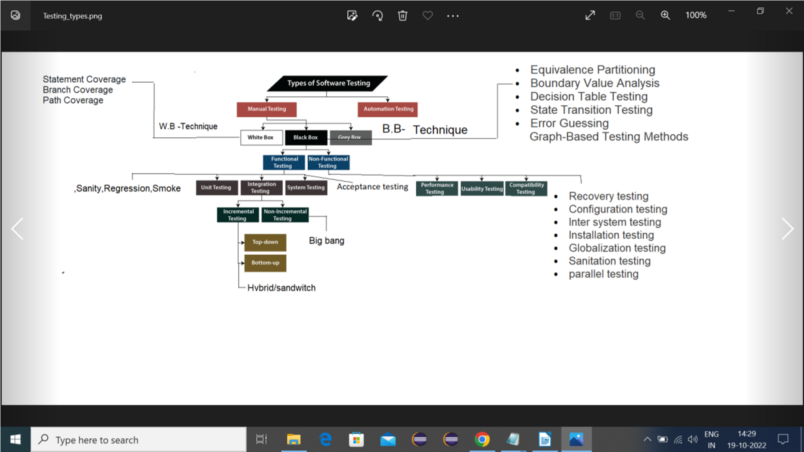

# Servers / Environments for an application till production

**Development Server**

A development server is a type of server that is designed to facilitate the development and testing of programs, websites, software, or applications for software programmers. It provides a run-time environment, as well as all hardware/software utilities that are essential to program debugging and development.

**QA/Test server**

A test server is a type of server that is designed to facilitate/validate the testing of programs, requirements, websites, software, or applications for software test engg.

**Staging/UAT/Preprod Server**

Staging is normally an environment which is normally a production replica (for configurations etc.) and changes need to be revieried here as it was verified in earlier environments post thorough testing.

Typically, Staging environment is stable server/environment, User Acceptance testing.

**Production /Live Server**

A production server is a type of server that is used to deploy and host live websites or Web applications. Undergone extensive development and testing before they are validated as production-ready.

A production server may also be referred to as a live server.

**Servers/Environments/Build/URL- Example**

1.DEV-dev.mmt.com

2.QA/LOCAL ENVIRONEMENT/SERVER:qa..makemytrip.com/ (example) Testing done here

Note:Dev and QA server may be same in some project and company.

3.Stage/pre-prod server/replica of prod server environement : stage1.makemytrip.com/ - client will review/test/crosscheck the requirement which was given [UAT]

**4.Production:https://www.makemytrip.com/**

**Total server – 4 and test server - 2**